Stepwise Refinement

David Graves
Colorado State University Global
CSC505
Dr. Steven Evans
February 17, 2025

Stepwise Refinement
A common colloquial refrain that is sometimes used when presented with a complex and large problem is that the best way to solve it is by taking ‘one bite of the elephant at a time’. This is a vivid image that helps the problem solver start to think through how one might find a solution by seeing the entirety of the problem, or scope, while at the same time getting a sense that it will require many underlying steps to complete the overall task of eating the elephant. In software and programming development this is also called stepwise refinement, and is viewed as, “the most effective way to solve a complex problem (is) by breaking it down into successively simpler subproblems”. (Roberts, 2016, Page 3, slide 6) This refinement approach requires levels or steps to incrementally produce better results. Leaning on the ‘elephant’ analogy you may start with a step of dismantling the elephant into smaller parts that may require 10 steps, but then taken another layer down each one of those 10 steps may require future refinement. That begs the question then, when does one stop refining steps? The best answer to that is, it depends and should be done “until programming language statements are reached” (Pressman & Maxim, n.d., Pg 167) which can vary depending on the problem. I’ll use the remainder of this paper to share a couple different approaches to mapping out what a stepwise refinement approach might be for a simple task-scheduling algorithm for an operating system, produce a high-level map and offer a working prototype solution based off the stepwise refinement mapping exercise.
Modeling in Action
When modeling a stepwise refinement approach including three levels of procedural abstractions for an operating system, one of the challenges is understanding what level the map should represent. In working through this exercise to develop a simple task-scheduling algorithm one could look at the stepwise refinement approach in a couple different ways.
One path would include steps outside specific algorithmic coding and include initial ‘procedural’ steps like spelling out high level requirements as step 1, detailing underlying steps required as step 2, and developing the algorithm that meets those requirements as step 3. Alternatively, all three levels of this refinement approach can be seen as underlying refinement steps within an algorithm itself, where 3 independent sub-tasks are updated via user input. Each one of the steps adds context and refines the overall solution in real time then ultimately feeds into one output that fits the overall operating system requirement. I believe both maps can be useful when developed during the appropriate stage of an operating system development lifecycle. For this exercise I chose to map out what a 3-level stepwise refinement approach could look like with the first high-level approach. This early project approach to mapping, that involves steps outside an algorithm are represented in Image 1 below.
Image 1 - UML ‘High Level’ Refinement Approach
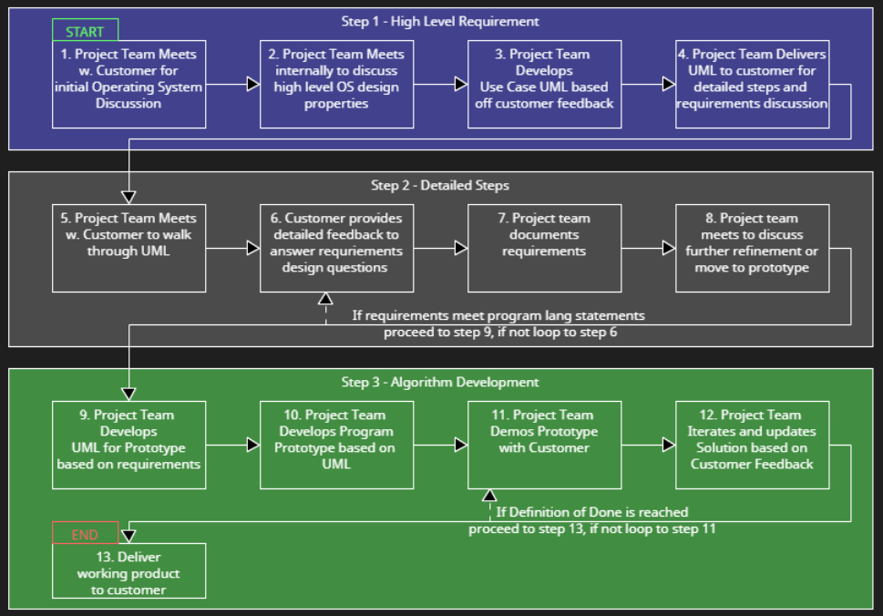
Taking this stepwise refinement mapping exercise one step further, I’ve produced a prototype Python algorithm for a task-scheduling program based on the 3rd step from the map in Image 1. The program itself also represents a stepwise approach by allowing a user to input tasks (step 1), view tasks to confirm progress (step 2), and to mark tasks as complete (step 3) where the data is refined as the user walks through the program and ultimately output in a clean display. The code for this is displayed in Image 2 below and it’s output in Image 3 below.
Image 2 (1 of 2) - Python code ‘Task-Scheduling Prototype’
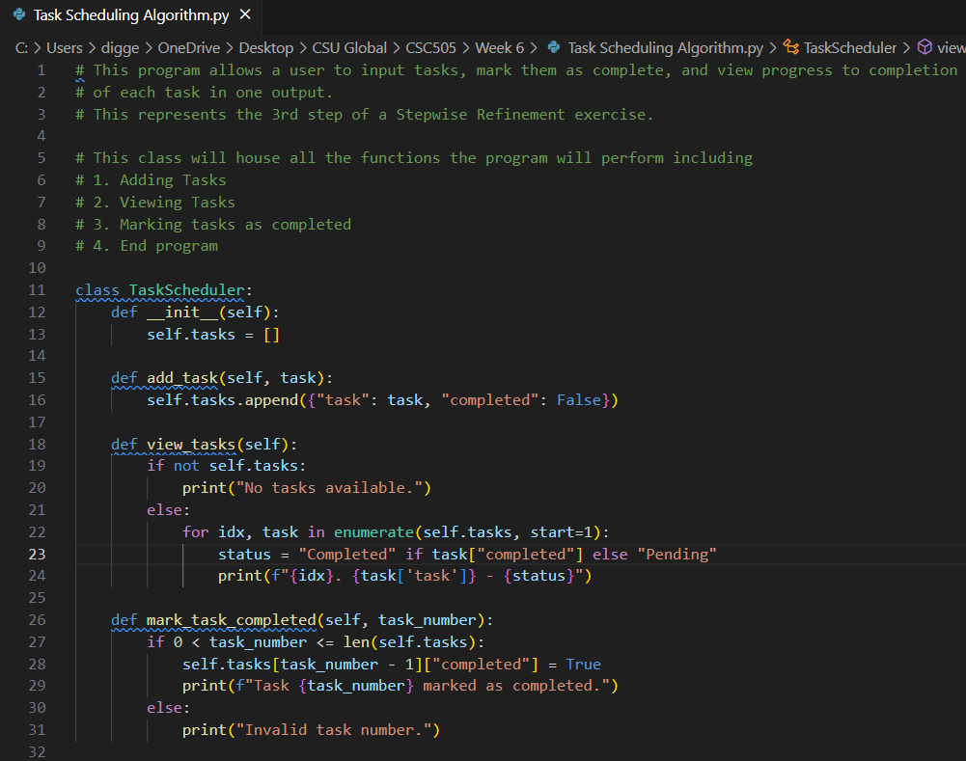

Image 2 (2 of 2) - Python code ‘Task-Scheduling Prototype’
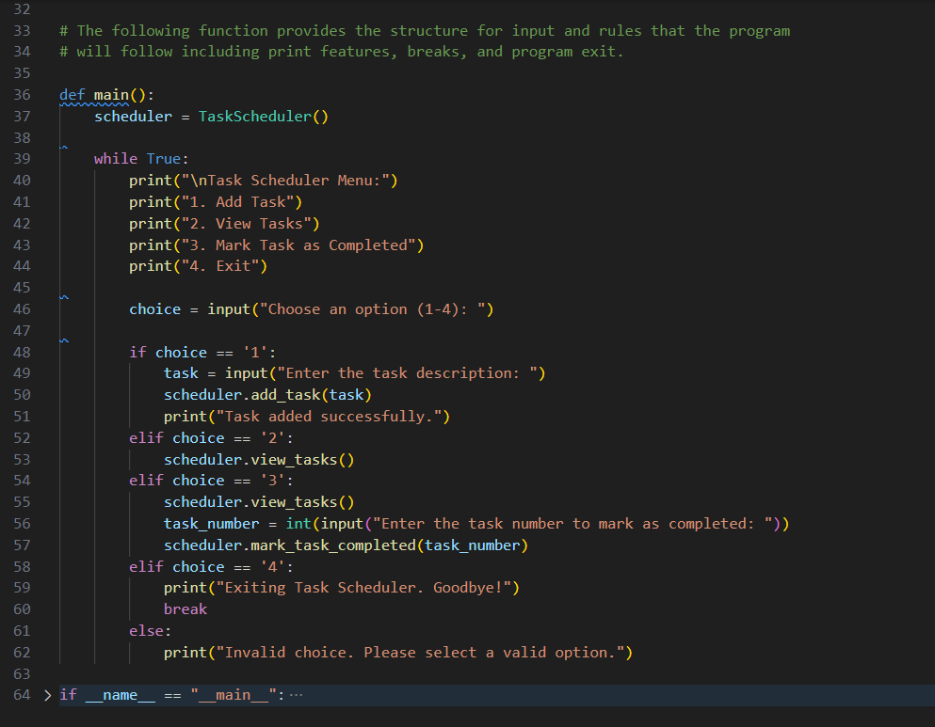
Image 3 (1 of 2) - Terminal Output ‘Task-Scheduling Prototype’
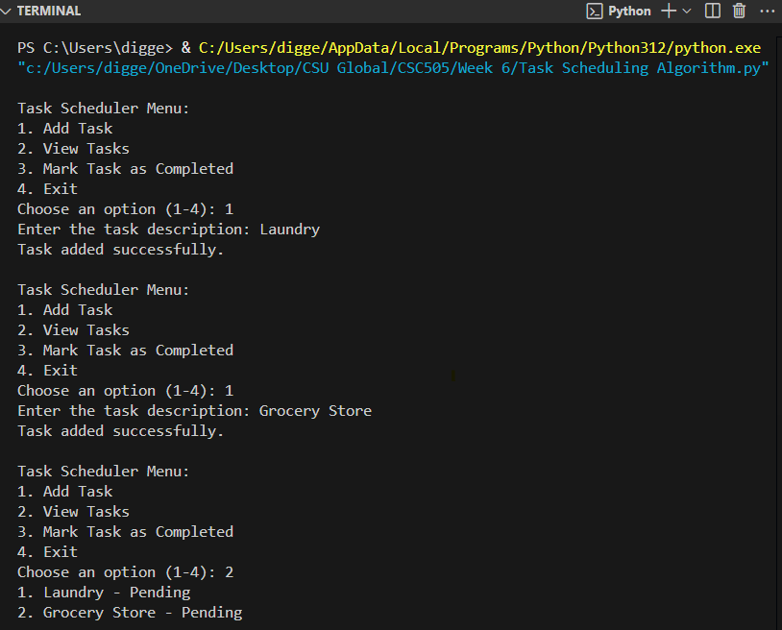
Image 3 (2 of 2)- Terminal Output ‘Task-Scheduling Prototype’
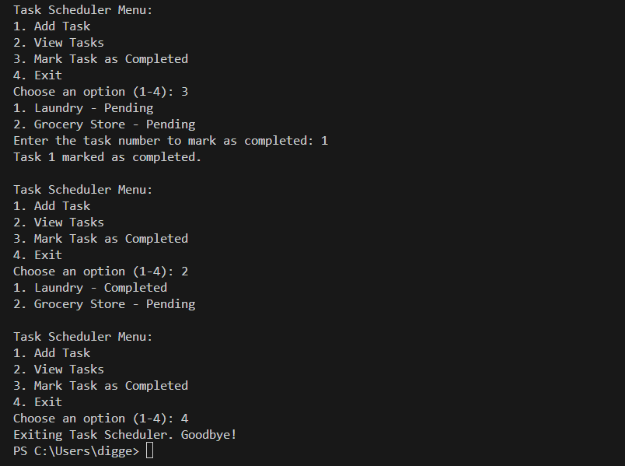
Reflection
This exercise proved challenging in understanding what level to provide mapping for the stated problem of creating the task-scheduling algorithm. In reflection, I found the key word to focus on was ‘refinement’. The intent of the map, and prototype at this level are to get in front of key stakeholders for feedback, and “is essential for ensuring that the final software product meets the desired requirements”. (Restack.io, 2025, Paragraph 1) This is a critical step in any project and especially helpful in software development where requirements can get confused between customer and project team. A good project manager should take every opportunity to encourage the production of these stepwise maps to gauge progress and to share with interested parties to ensure project alignment, and that the resulting product ultimately meets the needs of the customer.
References
Pressman, R. S., & Maxim, B. R. (n.d.). Software Engineering: A Practitioner’s Approach.
Retrieved from https://platform.virdocs.com/read/1490446/200/#/4/4
Restack.io (2025, February 7). Restack.io. What is Refinement in Software Engineering.
https://www.restack.io/p/ai-methodology-principles-answer-refinement-software-engineering
Roberts, Eric (2016, January 8). Web.stanford.edu. Stepwise Refinement.
https://web.stanford.edu/class/archive/cs/cs106a/cs106a.1164/handouts/10-StepwiseRefinement.pdf

